# Introduction

A comb generator is basically a periodic pulse generator. When viewed from frequency domain, such pulse train is represented by the fundamental frequency and its multiple harmonics. Generated pulse duty cycle and frequency dictate the spectrum profiles in the frequency domain. In general smaller duty cycle, which is characterized by narrow pulsewidth as well as fast rising and falling times, generates smoother and higher frequency spectrum profiles.

Comb generator, also known as radiation source, has been an important tool for electromagnetic compatibility (EMC) laboratories to ensure the quality of measurement results. Calibration is usually performed in the interval of 1-2 years. However in between calibration periods, frequent intermediate checks should be carried out to identify if there is any irregularities in measurement results. Also, self-check is also necessary when there is changing of connectors, cables, or equipements. For practical reasons comb generator is an essential tool in performing intermediate checks because it is usually portable, battery operated, and able to generate multiple frequencies simultaneously.

Comb generators can be categorized into conducted and radiated ones. Radiated comb generator essentially consists of periodic pulse generator and radiating elements. For EMC applications the frequency range covers from 30 MHz up to 1, 2, 5 or 6 GHz, depending on the highest internal frequency of the unit under test [1]. There are several ways to produce periodic pulses, for example using discrete silicon RF transistor, step recovery diode (SRD), tunnel diode non linear transmission line (NLTL), etc [2]. Pulse generators based on SRD and Schottky diode techniques are able to generate a pulse width of a few hundred picoseconds [3][4][5]. Another method exploiting differential AND gates of emitter coupled logic (ECL) devices shows that a pulse width of approximately 1 ns can be produced [6].

In [7] a radiated comb generator is constructed using inverter gates of TTL device, which produces periodic square waves. It is obvious that the frequency peaks shows fluctuant spectrum envelope profiles. This can be explained by the fact that the comb generator makes use of square waves instead of short pulses, and also TTL devices have relatively slow rising/falling edges (2-10 ns) [8]. Another design of comb generator using NAND gates also exhibits similar jagged spectrum envelope profiles [9]. However, for convenience purposes it is highly desirable that the spectrum envelope of comb generator should have a smooth and regular shape.

A simple and cost effective design of pulse generator employing CMOS D Flip-Flop 74AC74 is described in [10]. Although the generated pulse width is limited to about 6 ns, the ingenious design can be adapted to produce narrower pulses by using faster logic devices. In this paper, a comb generator using single-ended emitter coupled logic (ECL) D Flip-Flop is proposed. Antena. Pulse measurements in time domain and frequency domain are presented. Measurement in SAC 3m.

# Implementation

Criteria: simple, easy fabrication

This paper aims to design a simple and low cost radiated comb generator useable up to 1 GHz range. The comb generator consists of two main parts, i.e. a periodic pulse generator and a radiating element. The pulse generator implementation is based on positive emitter coupled logic D Flip-Flop (PECL DFF). For simplicity reasons, a rod monopole is chosen as the radiating element.

WHY CHOOSE ECL?

## Pulse generator

Squarewave oscillator

TTL to ECL level shifter

ECL pulse former

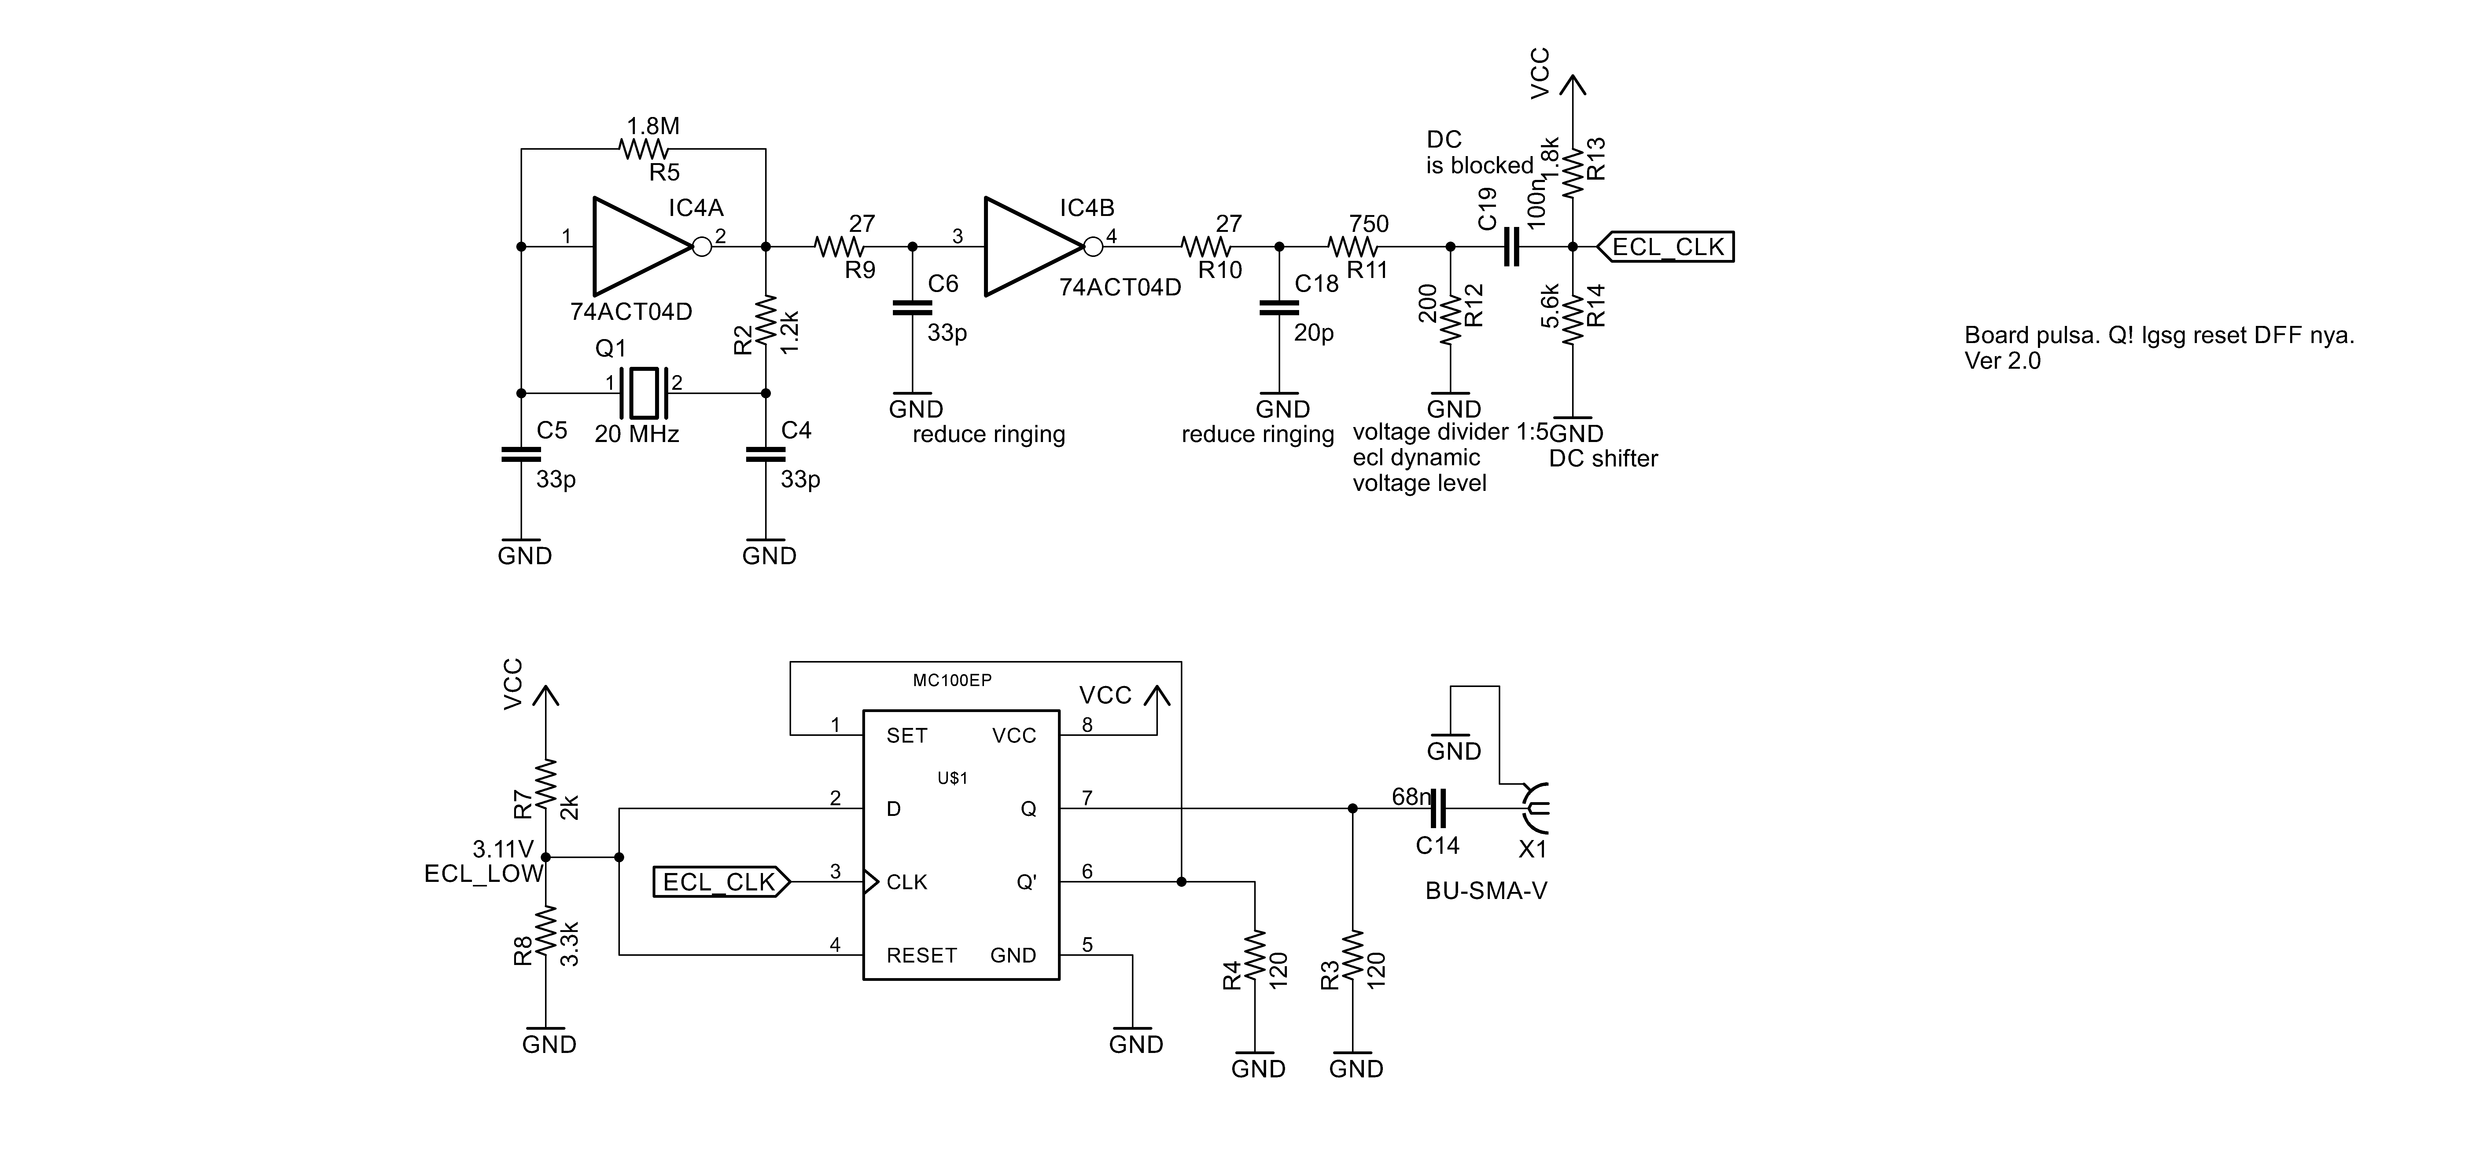

The pulse generator is powered at 5 volts, and consists of three main parts, i.e. square wave oscillator, TTL to ECL level shifter, and ECL pulse former. The square wave oscillator is constructed from 74ACT04 TTL-compatible CMOS inverter and a 10 MHz crystal. R9, R10, C6, and C16 functions as ringing filter at the inverter’s output. Unless damped, the ringing could disrupt power supply lines and eventually propagates to next stages in the circuit. As a result, the final pulse output may become deteriorated. The square wave has a TTL voltage level where a LOW is at 0 volts and HIGH is 5 volts. However positive ECL (PECL) has different voltage level definitions where 3.2 volts is a LOW and 4.0 volts is a HIGH. Therefore, TTL square wave is shifted to ECL level before fed to EP100 DFF.

MC100EP has a truth table as shown in Table 1. D and RESET are always held LOW. Incoming rising edge at CLK input causes Q become LOW and Q’ transits HIGH. Because Q’ output is tied to SET input, when Q’ is going HIGH, the Q is forced to HIGH state immediately irrespective of the CLK input. Q stays at HIGH state until the next rising edge of CLK input. As a result, such an abrupt SET action causes a very short downward pulse is generated at Q output.

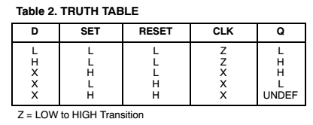

Gambar desain board..

[1] “CISPR 32:2015 - Electromagnetic compatibility of multimedia equipment - Emission requirements.” International Electrotechnical Commission.

[2] James R Andrews, “Picosecond Pulse Generation Techniques and Pulser Capabilities.” Picosecond Pulse Labs, pp. 1–8, 2008.

[3] M. Miao and C. Nguyen, “A uniplanar picosecond impulse generator based on MESFET and SRD,” *Microw. Opt. Technol. Lett.*, vol. 39, no. 6, pp. 470–472, Dec. 2003.

[4] J. Zhou, X. Yang, Q. Lu, and F. Liu, “A Novel Low-Ringing Monocycle Picosecond Pulse Generator Based on Step Recovery Diode,” *PLoS One*, vol. 10, no. 8, p. e0136287, Aug. 2015.

[5] E. Maxwell, T. Weller, and E. Odu, “Design and Analysis of a Multiport Circuit for Shaping Sub-Nanosecond Pulses,” *IEEE Trans. Microw. Theory Tech.*, vol. 56, no. 12, pp. 2764–2770, Dec. 2008.

[6] D. Ribeiro, P. M. Cruz, and N. B. C. Carvalho, “Evaluation of Comb Generator Performance for Nonlinear Measurements on Mixed-Domain Instrumentation,” in *URSI Seminar of the Portuguese Committee*, 2012, vol. 1, pp. 1–4.

[7] C. Dau-Chyrh, L. Chih-Hung, and Y. Tsung-Yuan, “Novel Design of Site Source for Radiation and Conduction Emission Test,” in *Progress in Electromagnetics Research Symposium Proceedings*, 2013, pp. 1033–1035.

[8] M. I. Montrose and IEEE Electromagnetic Compatibility Society., “EMC and the printed circuit board : design, theory, and layout made simple,” *IEEE Press series on electronics technology.* p. xviii, 325 p., 1999.

[9] V. Ungvichian and R. Aina, “A Study of Inexpensive Stable Conducted/Radiated Emission Sources Suitable for the EMC Directives,” in *2006 International RF and Microwave Conference*, 2006, pp. 296–300.

[10] L. Martin, “A Simple Low-Cost Comb Generator Frequency Calibrator,” pp. 78–82, 1988.